**Why Digital Marketing Is Essential For Your Startup**

Every day, new brands were launched in the market. These brands have to compete with the old company and millions of marketing campaigns. For startup, the only hope for success in marketing should be better and more efficient than the old business. Startups often have a limited budget, which means that they must make the most of their finances are limited in reach customers and grow revenue.

**Why Digital Marketing Is Important for Startups?**

Digital marketing can be done at lower cost than traditional marketing. While print and television ads can cost thousands of dollars, online advertising may only cost a few hundred dollars. Also, a blog can reach thousands of readers to the cost of making the article and pay for the server. [**Digital marketing strategy**](https://www.c4social.com/) allows startups to reach new clients and develop relationships at a fraction of the cost of traditional marketing.

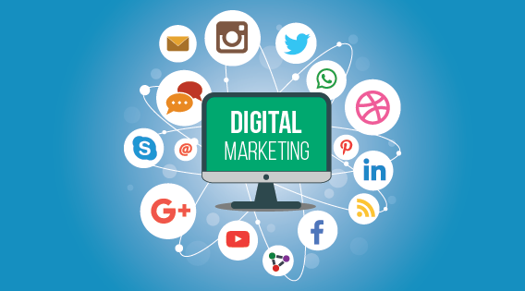

**Reasons why Digital Marketing is Important for Startups**

**Engage Clients**

Twitter campaigns, social media posts, and webinars all provide an opportunity to engage clients directly. Through digital marketing, customers feel like they have a personal relationship with the company. Once this relationship is developed, it takes a minimal amount of effort for a startup to keep their clients. In addition to involving clients, social media campaigns also help to drive traffic to a website and market the company's new offer.

**SEO Still Important**

While some people think that SEO is dying just a few years ago, it is still important for the website. Google might have updated their algorithm, but SEO is still the best way for search engines to decide what the site is about and how useful it was. As long as there are search engines, search engines will need some way to determine the topic and usability of a website.

**Use the Metrics to Drive Success**

Many consumers are using mobile devices to get online and find out about the product. Because of broad access to traditional computers and mobile devices, online marketing is one of the most efficient ways of marketing to consumers. Also, it offers real-time metrics for a startup to measure the success of their campaigns.

**Optimizing Conversion Rate**

Some startups believe that [**Digital Marketing Agency Orlando**](https://www.geni.com/people/c4-social/6000000109637485873) does not work because they do not generate leads. Part of the problem is that these startups forget to optimize their conversion rates. A post-social media can bring people to the website, but will not make a sale unless companies optimize the website. There should be an option to subscribe to an email list, buy a product or filling out a contact form on the site. The call to action at the bottom of the article or the button to sign up allows visitors to the site to become a paying client.

Digital marketing should be done immediately after the startup formed. From the beginning, digital marketing needs to become a core part of business strategy startup. For a business to be successful, it must reach out to new customers, develop leads and convert leads into sales.